JDK版本问题

# 异常1

2018-05-15报出异常信息：

**Unsupported major.minor version 52.0解决办法**

错误异常：

Error creating bean with name 'org.springframework.web.servlet.mvc.annotation.DefaultAnnotationHandlerMapping#0' defined in URL [file:/D:/develop/tomcat7/wtpwebapps/lotus_app/WEB-INF/classes/spring/springMVC-servlet.xml]: BeanPostProcessor before instantiation of bean failed; nested exception is org.springframework.beans.factory.BeanCreationException: Error creating bean with name 'org.springframework.transaction.config.internalTransactionAdvisor': Cannot resolve reference to bean 'org.springframework.transaction.annotation.AnnotationTransactionAttributeSource#0' while setting bean property 'transactionAttributeSource'; nested exception is org.springframework.beans.factory.BeanCreationException: Error creating bean with name 'org.springframework.transaction.annotation.AnnotationTransactionAttributeSource#0': BeanPostProcessor before instantiation of bean failed; nested exception is org.springframework.beans.factory.BeanCreationException: Error creating bean with name 'org.springframework.aop.aspectj.AspectJPointcutAdvisor#0': Instantiation of bean failed; nested exception is org.springframework.beans.BeanInstantiationException: Could not instantiate bean class [org.springframework.aop.aspectj.AspectJPointcutAdvisor]: Constructor threw exception; nested exception is java.lang.UnsupportedClassVersionError: com/jd/payment/app/ccmis/interceptor/UserInterceptor : **Unsupported major.minor version 52.0** (unable to load class com.jd.payment.app.ccmis.interceptor.UserInterceptor)

经验1：能够从报出的大量异常中，找到准确的原因。

超哥，直接就是找到了红色标注，然后百度一下，

<https://blog.csdn.net/superit401/article/details/72731381>

提供的就是版本过低的问题。

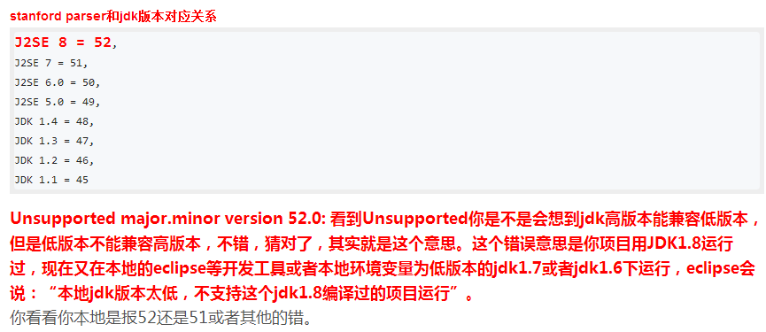

.接下来配置这几个地方jdk要一致：

1）看看你系统的jdk环境变量配置的是jdk那个版本

2）**Windows—— Preferences——Java——Compiler——设为jdk1.8**

3）**在此页面的Java——Installed JREs——设为jdk1.8**

4）**关闭此页面，项目右键（或者core包）——Build Path（也可是Properties）——Configure Build Path——Java Build Path——Libraries下面的JRE System Library改为jdk1.8（此处设置见参考3），保证旁边的Order and Export这个jdk与之相同**

5）**同页面的Java Compiler选项改为jdk1.8**

6）同页面的Project Facets——右侧的Java改为1.8（此项也可以不改）

7）如果上述还不管用的话试试：

修改org.eclipse.wst.common.project.facet.core.xml：

打开项目所在的文件夹，打开.settings文件夹，修改里面的“org.eclipse.wst.common.project.facet.core.xml”文件

如我的路径是：D:\cctv5cms\maven.1490956540309\cms-cms\cms-core\.settings\org.eclipse.wst.common.project.facet.core.xml

